# Operational Concept Description (OCD)

**LiveRiot Video Editing System and social networking enhancement**

**Team 04**

**Yang Li Project Manager, Life Cycle Planner**

**Haoyu Huang System Architect, Feasibility Engineer**

**Ye Tian Operational Concept Engineer, Prototyper**

**Zichuan Wang Prototyper, Operational Concept Engineer**

**Haishan Ye Requirement Engineer, Life Cycle Planner**

**Kaiqi Zhang Feasibility Engineer, System Architect**

**Mitra, Alok IIV&V**

12/08/2013

# Version History

| Date | Author | Version | Changes made | Rationale |
| --- | --- | --- | --- | --- |
| 09/25/13 | Team04 | 1.0 | * Tailored from IICSM OCD Template * Section 1 added * Section 2 added * Section 3.1 added | * To summarize and present the analysis of current system |
| 10/10/13 | Ye Tian | 2.0 | * Section 1.2 – Status of OCD updated * Section 3.2, 3.3, 3.4 added | * Add new operation concept to the existing system |
| 10/19/13 | Ye Tian | 2.1 | * Section 1.2 – Status of OCD updated * Section 2.3 – System boundary and environment changed to make it more precise * Section 3.2.1 – Some capability goals which don’t belong to our app deleted * Section 3.3.2 – Business flow out of our scope deleted | * Narrow the requirement scope to what we are working on in order to avoid scope creeping |
| 12/08/13 | Ye Tian | 2.2 | * Few update |  |

# Table of Contents

Operational Concept Description (OCD) i

Version History ii

Table of Contents iii

Table of Tables iv

Table of Figures v

1. Introduction 1

1.1 Purpose of the OCD 1

1.2 Status of the OCD 1

2. Shared Vision 2

2.1 Overview of the system 2

2.2 Benefits Chain Diagram 3

2.3 System Boundary and Environment 4

3. System Transformation 5

3.1 Information on Current System 5

3.2 System Objectives, Constraints and Priorities 6

3.3 Proposed New Operational Concept 8

3.4 Organizational and Operational Implications 9

# Table of Tables

Table 1: The Program Model 2

Table 2: Capability Goals 7

Table 3: Relation to Current System 7

# Table of Figures

Figure 1: Current Business Workflow Diagram 6

Figure 2: Element Relationship Diagram 8

Figure 3: New Business Workflow Diagram 9

### Introduction

#### Purpose of the OCD

This document provides, in detail, the shared visions and goals of the stakeholders of the LiveRiot Video Editing System and social networking enhancement. The success-critical stakeholders of the project are LiveRiot, as the project owner; musicians, fans and venues, as users; members of CSCI 577a Team 04, as developer.

#### ****Status of the OCD****

The status of the OCD is currently at the under-construction version number 2.1 in the Exploration Phase. The scope has been narrowed to social networking enhancement since another team is working on video editing part of this project. Currently the choice of this system’s maintainer has not yet been decided. The most likely option is that LiveRiot will maintain it themselves.

### Shared Vision

#### Overview of the system

Table 1: The Program Model

|  |  |  |  |
| --- | --- | --- | --- |
| * Fans would like to upload, edit videos on LiveRiot, * Musicians would like to communicate on LiveRiot, * Venues and musicians would use LiveRiot to improve their business | | | |
| **Stakeholders** | **Initiatives** | **Value Propositions** | **Beneficiaries** |
| * Developers * LiveRiot * Venues * Fans * Musicians * Record labels * Third-party E-commerce Service Providers | * Develop an online live music shows editing and sharing system * Manage high user traffic * Provide assistance to monetize live shows * Create working campaign * Pattern musicians with venues and record labels * Develop websites and apps with social functions | * Create a platform for high quality videos * Increase exposure of unsigned artists * Decrease piracy * Maintain musicians’ control over their art * Enhance communications between musicians and fans * Increase attendance to venues * More cooperation between venues and record labels | * Musicians * Venues * Fans * Record labels |
| **Costs** | | **Benefits** | |
| * Development costs * Maintenance costs * Hardware costs (recode devices) * Web services costs * Marketing campaign costs | | Decreased:   * Piracy   Increased:   * Attendance at venues * Musicians’ control over their art * Exposure of unsigned artists * Quality of live show videos | |

#### Benefits Chain Diagram

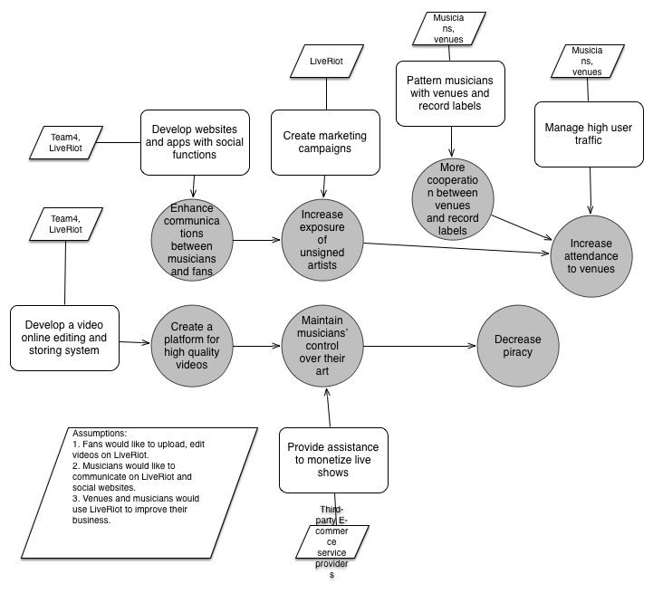

Figure 1: Benefits Chain Diagram

#### System Boundary and Environment

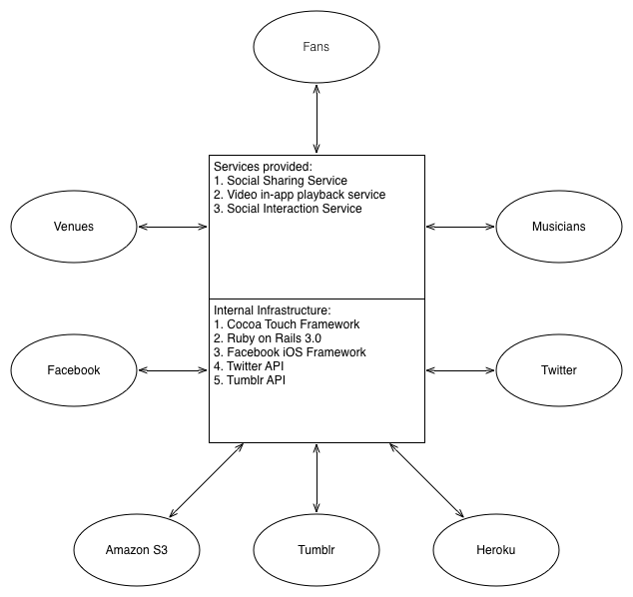

Figure 2: System Boundary and Environment

### System Transformation

#### Information on Current System

##### Infrastructure

1. Server side

1) Operating system: Linux version 3.8.11-ec2 (gcc version 4.4.3 (Ubuntu 4.4.3-

4ubuntu5.1))

2) Database: PostgreSQL v 9.2.

3) Web Server: written in Ruby on Rails and run on Amazon utilizing EC2 and S3

4) Video Editor: Node.js and Express

5) Digital Signal Processing: Faust

2. Client side

1) Apps: video record app, audio record app

2) Operating system: iOS

3) Database: Sqlite

4) Development platform: Mac OS

##### Artifacts

1. User Manual

Teach and guide the user how to use the product

2. Functioning Software System

The video recording app and website

3. System and Software Architecture Description

Object-oriented analysis and design (OOA&D) of the system being developed

4. Email notification system

Notify users when they create account and when new message come to them

5. Social video app template

Third-party video app templates

##### Current Business Workflow

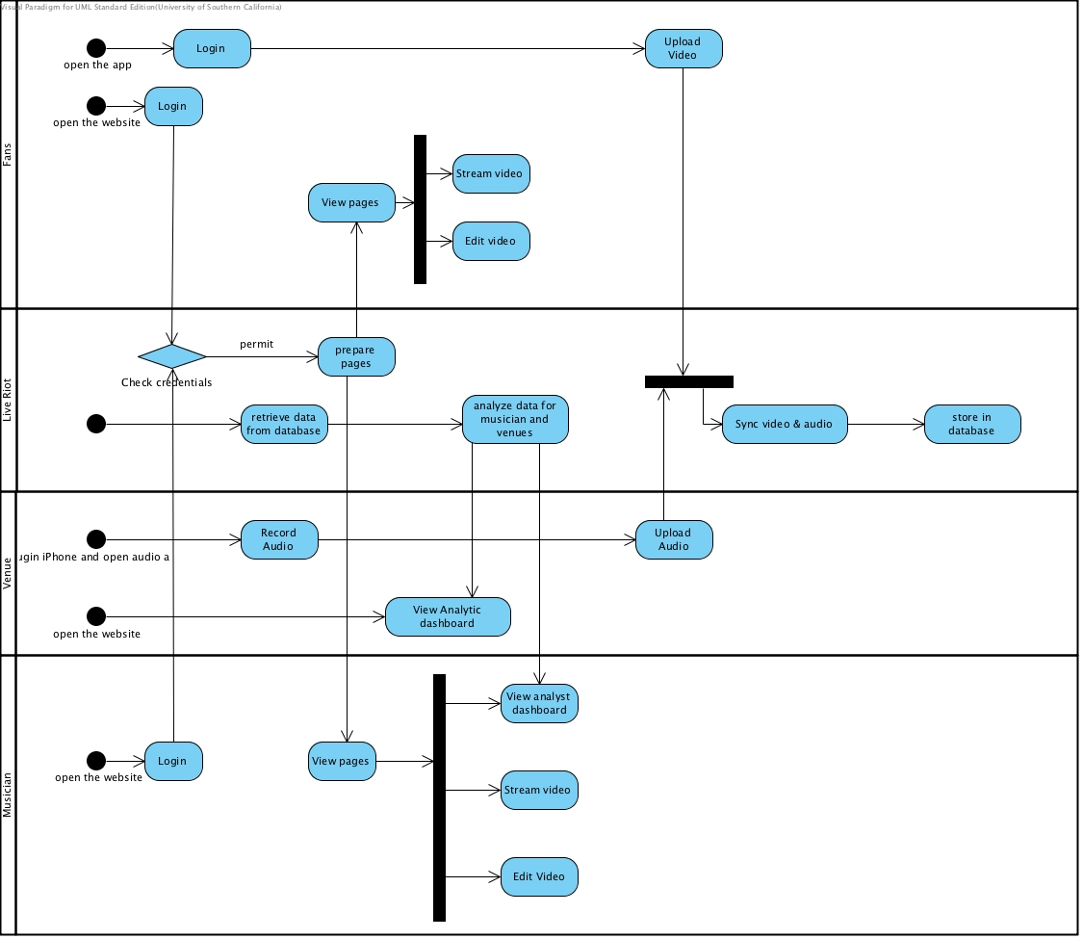

Figure 1: Current Business Workflow Diagram

#### System Objectives, Constraints and Priorities

##### Capability Goals

Table 2: Capability Goals

|  |  |
| --- | --- |
| **Capability Goals** | **Priority Level** |
| **OC-1 Social function**: The system is capable of sharing videos to famous social media, such as Facebook and Twitter. | Must have |
| **OC-2 Featured videos lists**: The app is capable of listing videos with features provided by LiveRiot server. | Must have |
| **OC-3 Video tagging**: The app is capable of tagging videos captured by fans and venues for effective searching. | Should have |
| **OC-4 Video searching:** The system is capable of searching for bands by genre, location, keywords and band name. | Should have |

##### Level of Service Goals

This section is not applicable because clients didn’t specify any level of service goals.

##### Organizational Goals

**OG-1:** Provide a platform for concert videos with high quality audio

**OG-2:** Increase venues’ attendance

**OG-3:** Decrease piracy of musician works

##### Constraints

**CO-1:** App: App will be provided on iOS appstore

**CO-2:** Server: Website will be held on Amazon EC2 and written in Node.js

**CO-3:** Database: The backend database must use PostgreSQL

**CO-4:** Operating system: The system will run on Linux

##### Relation to Current System

Table 3: Relation to Current System

|  |  |  |
| --- | --- | --- |
| **Capabilities** | **Current System** | **New System** |
| Roles and Responsibilities |  | There aren’t any new roles in the enhanced system. |
| User Interactions | Fans used video record app to record videos and upload them to LiveRiot. | Fans use video record app to record videos, upload them to LiveRiot, watch their own and others’ videos and share them on social websites like Facebook and Twitter. |
| Infrastructure |  | Using the same infrastructure to support the web interface and iOS app. |
| Stakeholder Essentials and Amenities | Users can only share their videos by pasting the websites’ links. | Users (Fans, musicians and venues) will be able to share their videos more conveniently and timely. |
| Future Capabilities | Users have limited methods to explore their business and build relations with one another. | Apart from plenty ways to edit and polish videos, users in the community will be able to have more methods to share their works |

#### Proposed New Operational Concept

##### Element Relationship Diagram

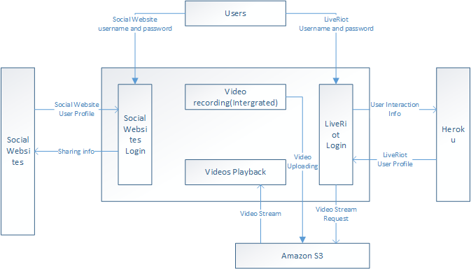

Figure 2: Element Relationship Diagram

##### Business Workflows

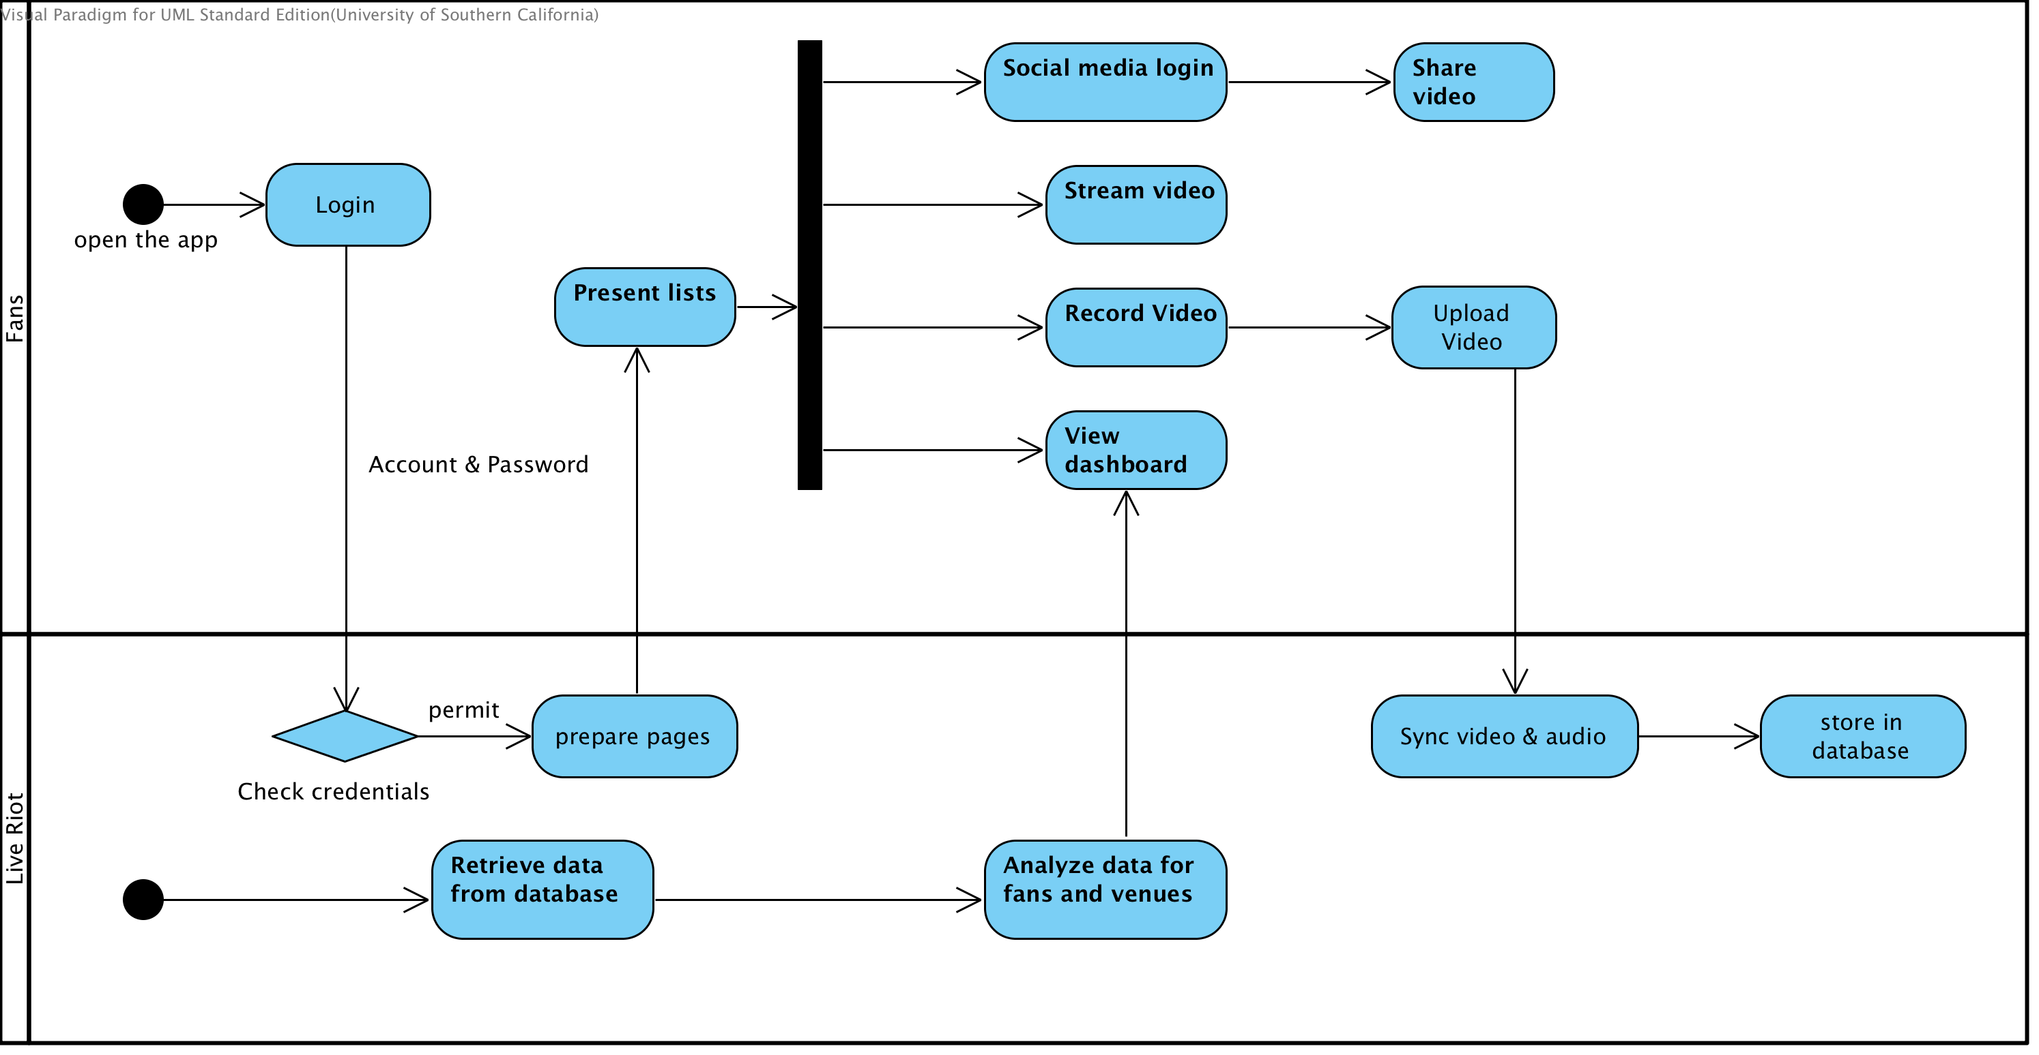

Figure 3: New Business Workflow Diagram

#### Organizational and Operational Implications

##### Organizational Transformations

There won’t be any significant organizational transformations since there was already such a video record app for fans and the whole system is just going through some enhancement.

##### Operational Transformations

* Fans will need to adapt to the new user interface of video record app, since iOS has been upgraded to a new version.
* After watching a video or reading the summary, fans can choose to share it to social websites (Facebook, Twitter).
* There will be featured video lists for fans, whose features (Top 10, newest) are fixed.
* Fans will be able to view their videos on both the website and the app.
* Searching for videos by tags, attributes (band name, genre, location and keywords) rather than going to various musicians’ pages to watch videos.